Barcode on 96 well plates

Scanned:
text encoded by this barcode is: TF0RACK01T101A
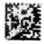 text encoded by this barcode is: TF0RACK01T101Z
Note that code is the same for all 96-well plate, even the deep and square ones.
Used ZXing Decoder to identify bar code type:
https://zxing.org/w/decode.jspx
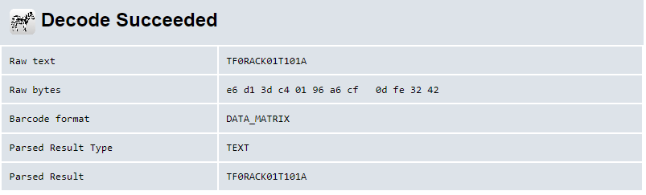
I used two different data-matrix barcode generators:
https://www.barcodefactory.com/datamatrix-barcode-generator
https://www.barcode-generator.de/en/create-datamatrix

TF0RACK01T101A barcode-generator.de.jpg 1_TF0RACK01T101A

TF0RACK01T101Z barcode-generator.de.jpg 2_TF0RACK01T101Z
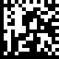

Created new tag
Original sticker size is ~9mm x 38 mm
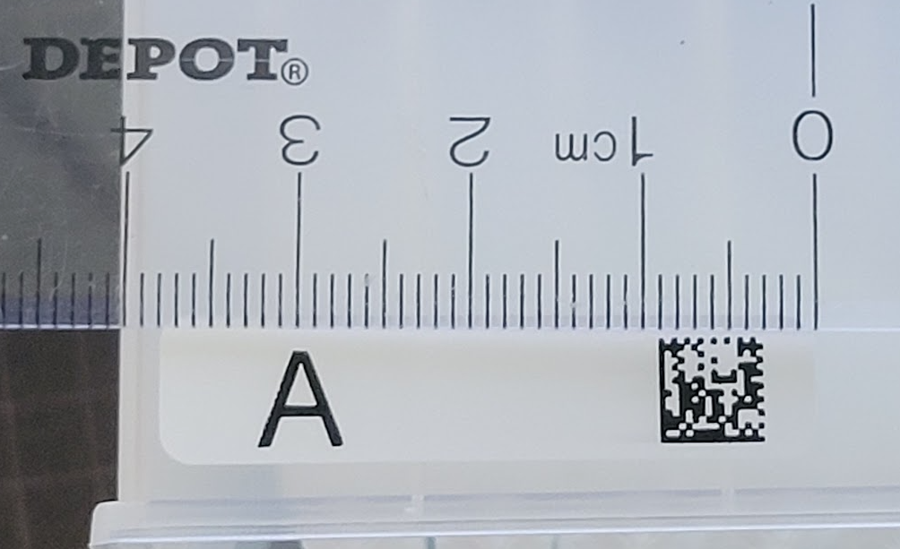
9mm x 38mm

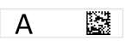
the size of the printed area is ~7mm x 30mm
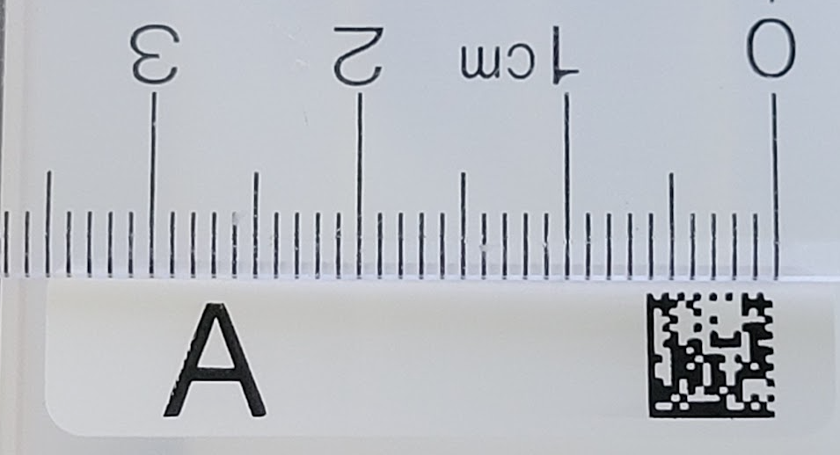

Use these tags to print labels
e.g. Tough-Tags (TTLW-2016 white, 0.5 x 1.28 in) or Avery (e.g. Waterproof Rectangle Labels with Sure Feed, .5" x 1.75", 80 White Labels per sheet (36545 or 36547))
A
A
A
A
A
Z
Z
Z
Z
Z

Barcode placement:
Lower left corner of the plate, +/- 0.25in horizontal (left to right) should work
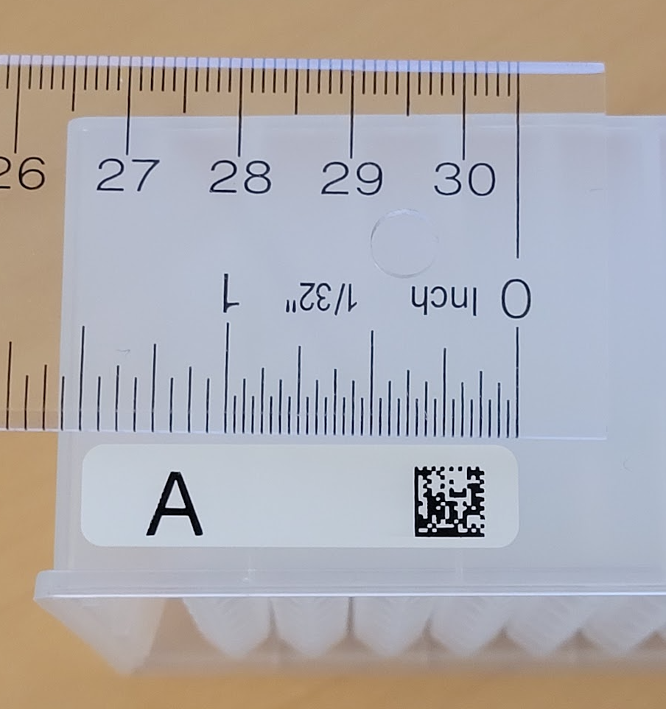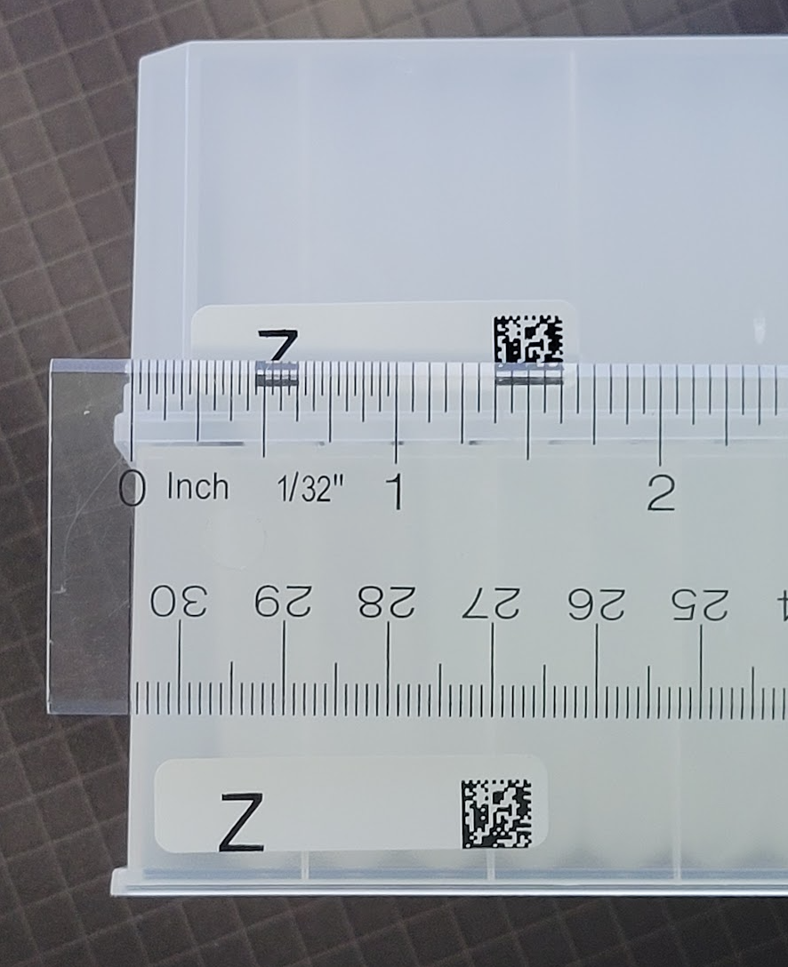
Label A on the side of row A and label Z on the side of row H:
