MassSpecUtils (a.k.a “TagTraq”)
MassSpecUtils is a tool that provides a Windows-based graphical user interface to perform the following tasks:
- Create mgf files from raw data files via ProteoWizard's msconvert tool. (Note: It is possible to convert to other formats supported by msconvert)
- Run Hardklör on raw data files.
- Create mzXML files from mgf files.
- For iTRAQ data, merge low mass range iTRAQ reporter ion peaks from HCD scans into CID scans of an mgf file to be used in a Mascot MS/MS search.
- Calculate potential "contaminants" introduced by iTRAQ labeling (TagTraq) using Mascot search results. Potential contaminant peaks, measured in the precursor scans, are determined using Hardklör.

Installing and Running MassSpecUtils
Pre-requisites:
- Ensure you have a fairly recent version of Xcalibur installed on your computer.
- Ensure you have the latest Thermo MSFileReader binaries installed.

To acquire the installation files for MassSpecUtils, please contact Tahmina “Eva” Baker at the UW Proteomics Resource (tabaker@uw.edu). As of 08/2015, Eva has moved on to bigger and better things so direct inquiries to Jimmy Eng (engj@uw.edu). Once you have these files, please follow the directions below:
- Copy the installation files to a Windows computer running Vista or higher.
- Double click on the “setup.exe” file to run the installer.
- Follow the directions provided by the setup wizard to install the tool.
- After a successful installation, you should see a MassSpecUtils folder in your computer’s Start menu. Click on the MassSpecUtils tool in this folder to run the tool, and you should see the following window:

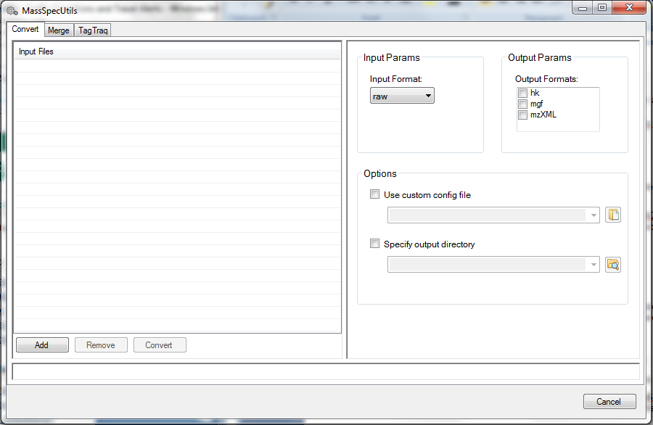

Special Instructions for Running on an XP Machine
It is possible to run MassSpecUtils on an XP machine, but you won’t be able to use the installer. The steps involve the following:
- Update to the latest Xcalibur installation.
- Update to .NET 4.0.
- Download and install ProteoWizard directly from their website.
- Let Eva know that you are trying to run the MassSpecUtils tool on an XP machine, and get MassSpeUtils files from her to copy into the ProteoWizard directory.
- Once you have copied the files, double click on “MassSpecUtils.exe” in the ProteoWizard directory to run the tool.

Converting Files
The tool provides functionality to perform the following mass spec file conversions:
- “raw” data file “mgf” file
- “raw” data file “mzXML” file
- “raw” data file Hardklör’s “hk” file
- “mgf” file “mzXML” file
- “mzXML” file “dta” file
- “pep.xml” Sequest search output file Sequest search output “txt” file

Let’s say I have an input raw data file that I wish to use to generate both both mgf and mzXML files. To do this,
- Click on the Convert tab at the top of the window.
- On the right-hand side of the window, in the Input Params group, select “raw” from the Input Format drop-down menu.
- In the Output Params group, click the checkboxes next to the “mgf” and “mzXML” Output Formats to select these.
- On the left-hand side of the window, click on the Add button below the Input Files list.
- Use the Open File Dialog to browse to the files you wish to convert, select these files, and click Open.
- In the Input Files list, click on the checkboxes next to the names of the files you would like to convert. For my particular example, here’s what the window looks like at this point (note that I am ignoring the “Use custom config file” and “Specify Output Directory” Options, but you may wish to specify these):
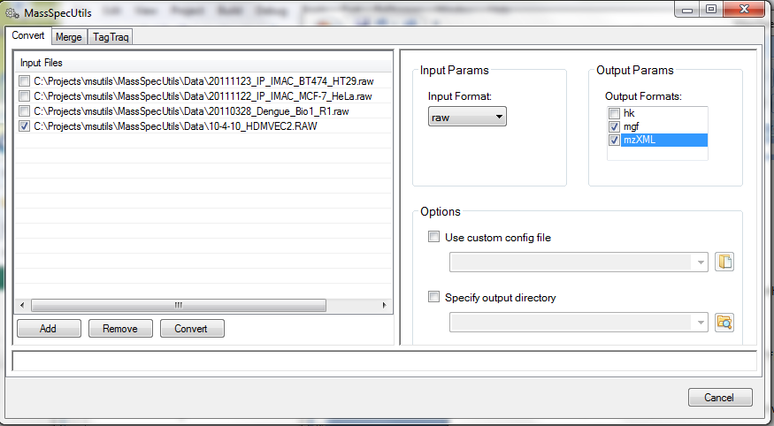

- Click on the Convert button below the Input Files list. While the files are being converted, you should something like the following:

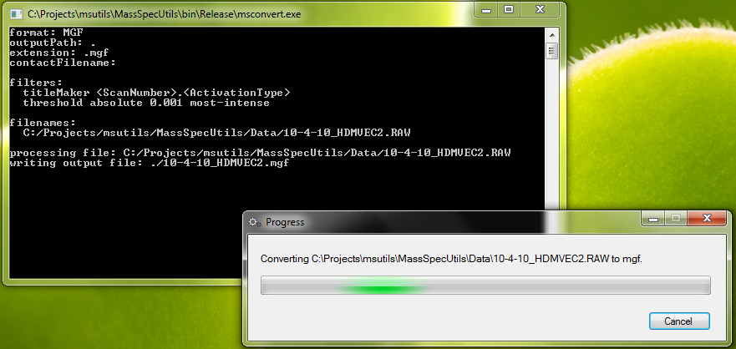

- Once the files have been converted, you should see the following message:

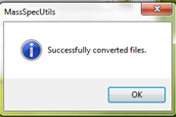

- Unless you use the “Specify output directory” Option, by default, the output files will be placed in the same directory from which you are running the tool.

Merging Files
MassSpecUtils also provides functionality to merge low mass range iTRAQ reporter ion peaks from HCD scans into CID scans of an mgf file. You can use the tool’s “Convert” functionality to create the mgf file from your raw data file (please see the previous section “Convering Files”).
For example, let’s say that I have an iTRAQ experiment where the reporter ions range in mass from 113-121, and in my instrument method, I specified the pattern “5 HCD reporter ion scans, followed by 5 corresponding full MS/MS CID scans”. To perform a merge, I would then do the following:
- Use the Convert tab to convert the raw file to mgf (see the “Converting Files” section for details)
- Click on the Merge tab at the top of the window.
- On the right-hand side of the window, in the Reporter Params group,
  - Type “113” in the Reporter Min Mass text box.
  - Type “121” in the Reporter Max Mass text box.
- In the Scan Params group,
  - Select the CID scan type for your main experimental data from the Full MS/MS Scan Type drop-down list.
  - Select the high-energy collision-induced dissociation scan type for your reporter ion peaks from the Reporter Ion Scan Type drop-down list.
  - In the First Scan Expected drop-down list, select the high-energy collision-induced dissociation scan type (because in my example method, I specified that I wanted to collect the HCD scans FIRST)
  - Type “5” in the Num Consecutive Scans text box (because in my example method, I specified that I wanted to collect 5 consecutive scans of each scan type at a time)
- If you would like to specify the output directory where you want to place your merged mgf file, in the Options group, check the Specify output directory check-box, and type in the path you want (by default, the path is the same as the input file’s path).
- On the left-hand side of the window, click on the Add button below the Input Files list.
- Use the Open File Dialog to browse to the files you wish to merge, select these files, and click Open.
- In the Input Files list, click on the checkboxes next to the names of the files you would like to merge. For my example, here’s what the window looks like at this point:

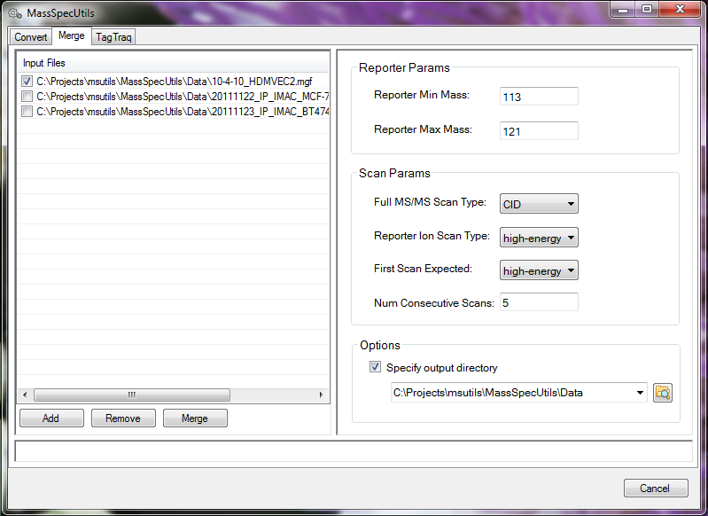
- Click the Merge button below the Input Files list. You should see something like the following message window pop up:
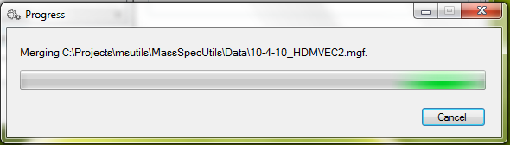

- Once the files have been converted, you should see the following message:

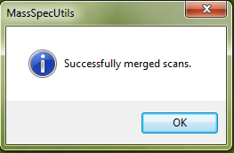

Using TagTraq
The TagTraq part of the MassSpecUtils tool allows you to calculate potential “contaminant peaks” introduced by iTRAQ labeling in the search results. Currently, the search tools supported are Mascot and SEQUEST. The potential contaminant peaks, measured in the precursor scans, are determined using Hardklör. Thus, to use this functionality, the following input file types are required:
- Merged “mgf” file – created from your raw data file using a combination of the Convert and Merge functionalities discussed above.
- Hardklör “hk” file – created from your raw data file using the Convert functionality.
- Search output file – containing the results of the search you performed using the merged mgf file above; can either be a Mascot csv file or a SEQUEST text file.

